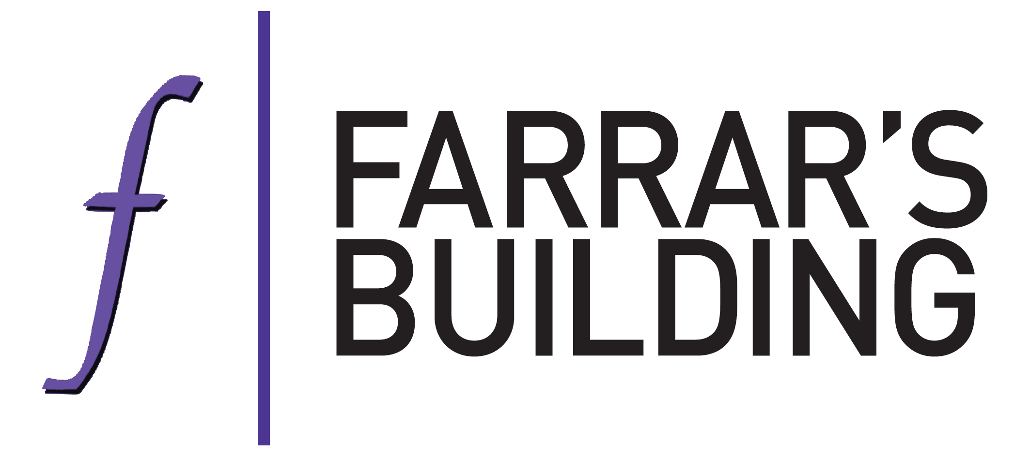

**Visitors Coronavirus Declaration Form**

Due to the ongoing novel coronavirus pandemic (COVID-19), we are requiring all visitors to Farrar’s Building (hereafter ‘Chambers’) to make a health declaration.

Chambers will rely on this declaration to protect your health and the health of staff, members of Chambers and visitors. Each visitor must complete this form prior to their appointment, please send it back to Chambers’ clerking team.

1. I confirm that I ***will not*** attend Chambers if any of the following apply:
2. I am currently experiencing any of the COVID-19 main symptoms, including:

* a high temperature – this means you feel hot to touch on your chest or back (you do not need to measure your temperature)
* a new, continuous cough – this means coughing a lot for more than an hour, or 3 or more coughing episodes in 24 hours (if you usually have a cough, it may be worse than usual)
* a loss or change to your sense of smell or taste – this means you've noticed you cannot smell or taste anything, or things smell or taste different to normal

1. I have tested positive for Covid-19 within the last 5 days ***OR*** have tested positive within the last 10 days and have not yet returned two negative test results;
2. I have entered the UK from another country within the last 14 days where current government policy requires me to self-isolate.
3. I am not fully vaccinated; ***and***

* either I have or someone else in my household has been in contact with a person with a confirmed case of COVID-19 in the past 10 days; ***and***

* I have been advised to self-isolate by the government’s track and trace service or by a medical professional.

1. I agree to comply with all applicable government guidance on social distancing and self-isolation during my visit and any site rules issued by Chambers.

Full name ……………………………………………………………

Signature ……………………………………………………………

Address………………………………………………………………………………………………………………………………………………………………………………………………………………………………………………………………………………………………………………………………………………………………………………………………

Contact telephone number ……………………………………………………………

Date ……………………

If you are unable to make the above declaration, please inform us and do not visit Chambers.

If during your visit you experience any of the above symptoms, you must immediately notify your host or a member of Chambers’ staff.

We are collecting and processing this personal data in accordance with our privacy policy and on the basis of it being necessary for the purposes of our legitimate interests in protecting the health of our staff and visitors. We do this as a preventive measure to mitigate the risk of a novel Coronavirus disease (COVID-19) outbreak on our site.